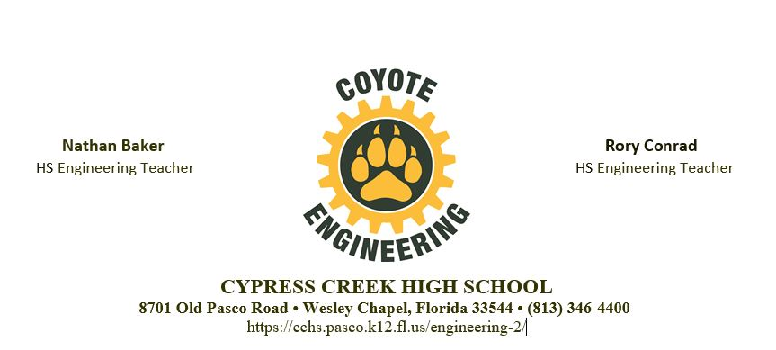
Engineering Academy Scholarship Application
Provide a one-time $500 scholarship to assist a student with the expenses of attending an accredited college or university. Submit completed application to nbaker@pasco.k12.fl.us by April 16. 2021.

Name: Click or tap here to enter text.

Years within CCHS Engineering Academy: Choose an item.

Pass the Inventor Certification Exam? Choose an item.

Weighted GPA? Click or tap here to enter text.

Documented hours of community service? Click or tap here to enter text.

Essay
If you could go back in time four (4) years, what three changes would you make? (750 word limit). Scoring based on maturity, depth of answer, grammar and spelling
Click or tap here to enter text.

