SUBLIMATED VARSITY JACKET

ORDER FORM

Student: _________________________________

Grade: _________________

Phone: _________________

COLOR | ITEM | S | M | L | XL | XXL | 3XL |  | OTY | UNIT PRICE | TOTAL
GRAY | ¼ ZIP |  |  |  |  |  |  |  |  | $80.00
GREEN | ¼ Zip |  |  |  |  |  |  |  |  | $80.00
GRAD YEAR ON SLEEVE:
NUMBER ON SLEEVE:
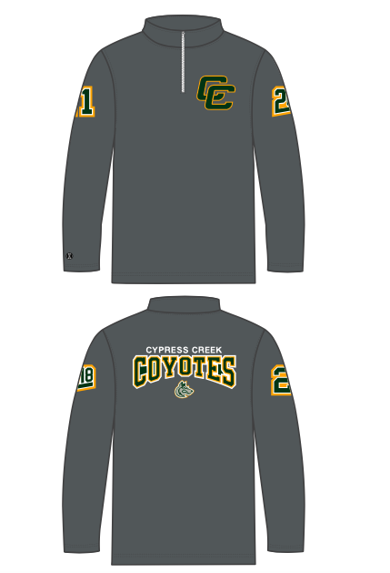  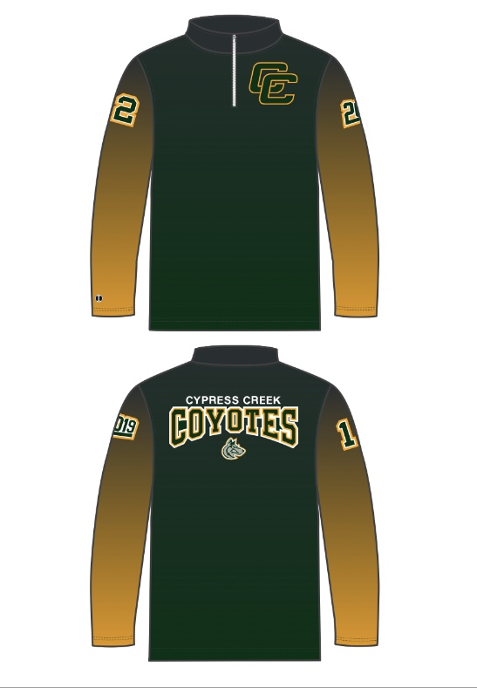 |  | 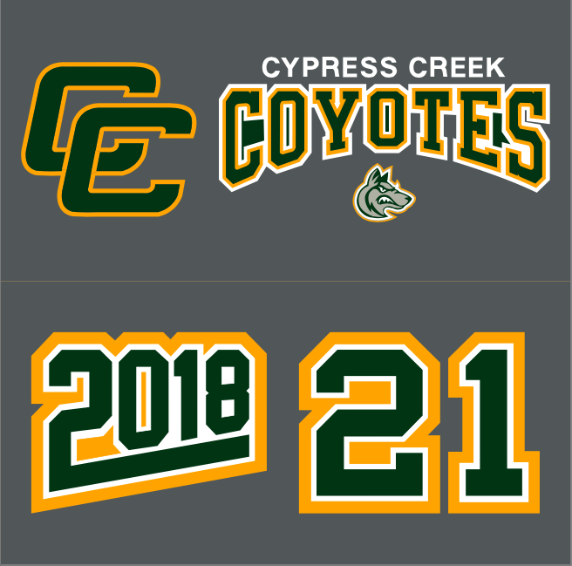
 |  |  |  |  |  |  |  |  |  | TOTAL

Submit paperwork with payment to High School Athletic Director, Coach Pelliccia.

